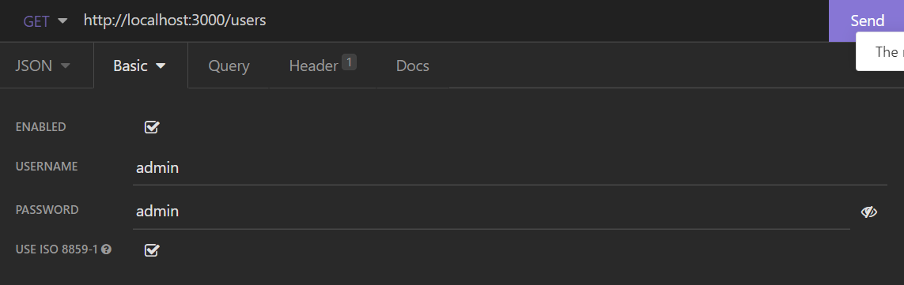

if we send a basic authentication. it will be received, as a header, this way:

 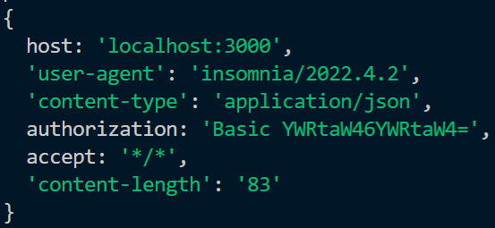

'Basic YWRtaW46YWRtaW4=' this is a bas64 authentication. this is the simplest type of authentication.